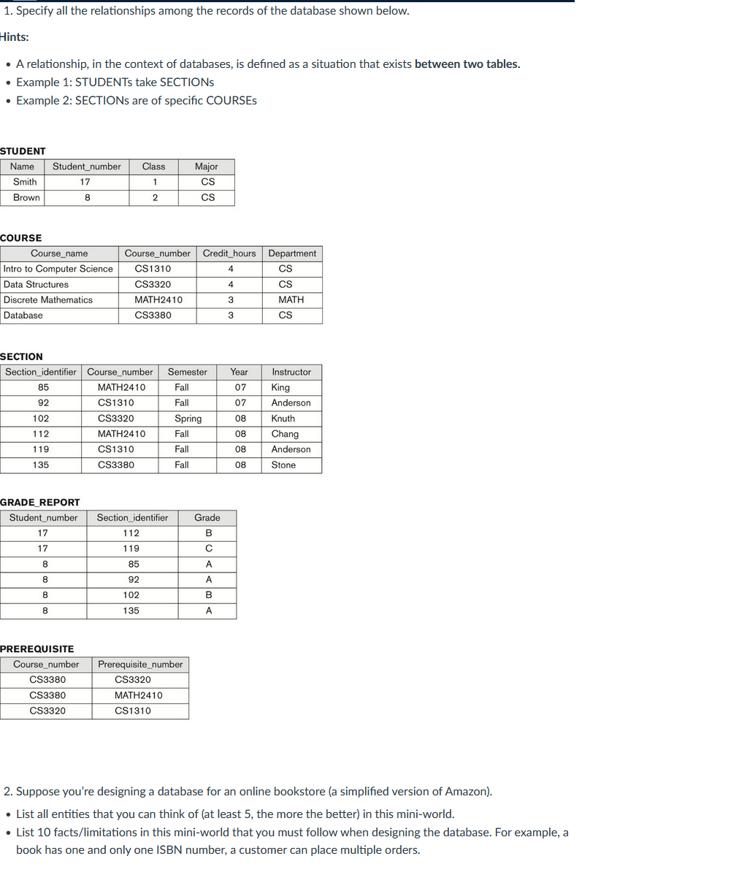
1.
- Sections are of specific courses
- Students take sections
- Courses have prerequisite courses.
- Students major in departments
- Courses are offered by departments.
- Students contain grades in grade report
- Sections contain section_identifiers located in grade report
- Instructors teach sections

2a. Shopping Cart, Author, Publisher, Book, Warehouse, Customer, Customer Orders, Genre, Language, Reviews
2b.
- A book can contain reviews from a customer.
- Warehouse may not have certain books available in which the amount of said books available needs to change upon purchase of said books (out of stock for example).
- Customers can make multiple orders for books,
- Each order a customer makes can contain different books or multiple books.
- Each order made through the website is tied to an individual’s account.
- Each book has a unique identifying number(isbn).
- Each book is assigned to a genre
- Books can contain multiple authors.
- Each book has a publisher.
- Each customer can use different paying methods.
- Each book has a certain language.
- Customers can use different shipping addresses.

